SNOWFLAKE SQL PRACTICAL
Subject: Data Foundations
Platform: Snowflake Cloud Data Warehouse
Topic: Database Creation, Warehouse Management, Table Creation, CSV Data Loading and SQL Operations
Objective:
To understand and practise Snowflake SQL operations by creating a database, managing schemas and virtual warehouses, creating tables, preparing CSV file formats, uploading files to internal stages, and loading and verifying data using SQL commands.

PART 1: DATABASE AND SESSION MANAGEMENT
Step 1: Check Current Session Information
Objective: To retrieve information about the current Snowflake session.
SQL Command:
SELECT
CURRENT_USER() AS USER_NAME,
CURRENT_ROLE() AS ACTIVE_ROLE,
CURRENT_WAREHOUSE() AS ACTIVE_WAREHOUSE,
CURRENT_DATABASE() AS ACTIVE_DATABASE,
CURRENT_SCHEMA() AS ACTIVE_SCHEMA;
Explanation:
- CURRENT_USER() displays the logged-in user.
- CURRENT_ROLE() displays the active role.
- CURRENT_WAREHOUSE() displays the active virtual warehouse.
- CURRENT_DATABASE() displays the selected database.
- CURRENT_SCHEMA() displays the selected schema.
Observation: The query displays the current Snowflake session details and helps identify the active working environment.

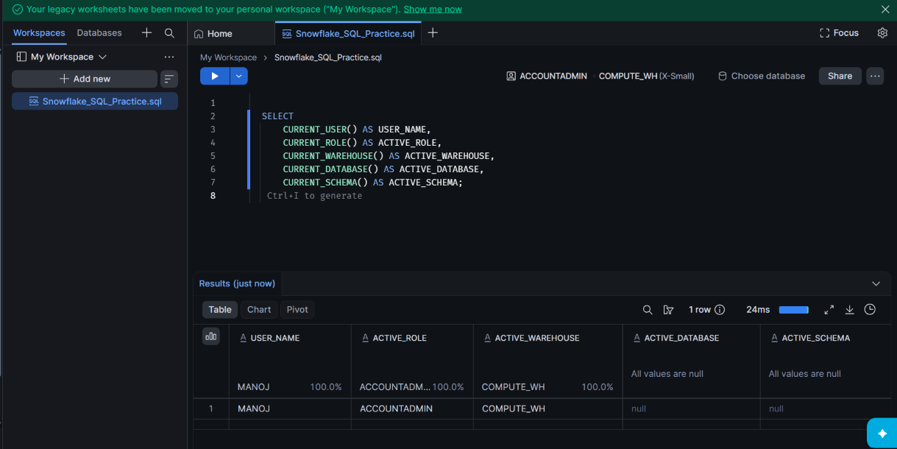

Step 2: Create a Database
Objective: To create a new database in Snowflake for storing company-related information.
SQL Command:
CREATE DATABASE IF NOT EXISTS COMPANY_DATA;
Explanation:
- CREATE DATABASE creates a new database.
- IF NOT EXISTS avoids errors if the database already exists.
- COMPANY_DATA is the name of the database.
Verification Command:
SHOW DATABASES LIKE 'COMPANY_DATA';
Observation: The database was created successfully and verified using the SHOW DATABASES command.

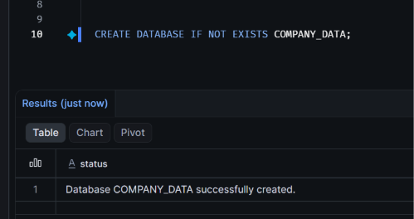

Step 3: Create a Schema
Objective: To create a schema inside the COMPANY_DATA database for organizing employee-related database objects.
SQL Command:
CREATE SCHEMA IF NOT EXISTS COMPANY_DATA.HR_RECORDS;
Explanation:
- CREATE SCHEMA creates a new schema.
- IF NOT EXISTS prevents an error if the schema already exists.
- COMPANY_DATA is the database name.
- HR_RECORDS is the schema name.
Select the Schema:
USE SCHEMA COMPANY_DATA.HR_RECORDS;
This command selects HR_RECORDS as the active schema.
Verification Command:
SHOW SCHEMAS IN DATABASE COMPANY_DATA;
SELECT CURRENT_SCHEMA();
Observation: The HR_RECORDS schema was created inside the COMPANY_DATA database and selected successfully for subsequent operations.
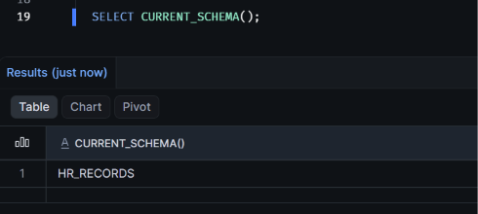

PART 2: VIRTUAL WAREHOUSE MANAGEMENT
Step 4: Create a Virtual Warehouse
Objective: To create a virtual warehouse in Snowflake that provides the computing resources required to execute SQL queries.
SQL Command:
CREATE WAREHOUSE IF NOT EXISTS STAFF_WH
WAREHOUSE_SIZE = 'XSMALL'
AUTO_SUSPEND = 60
AUTO_RESUME = TRUE
INITIALLY_SUSPENDED = TRUE;
Explanation:
- CREATE WAREHOUSE creates a virtual warehouse.
- IF NOT EXISTS prevents an error if the warehouse already exists.
- STAFF_WH is the warehouse name.
- WAREHOUSE_SIZE = 'XSMALL' specifies the smallest standard warehouse size.
- AUTO_SUSPEND = 60 automatically suspends the warehouse after 60 seconds of inactivity.
- AUTO_RESUME = TRUE allows the warehouse to resume automatically when required.
- INITIALLY_SUSPENDED = TRUE creates the warehouse in a suspended state.
Select the Warehouse:
USE WAREHOUSE STAFF_WH;
This command selects STAFF_WH as the active virtual warehouse.
Verification Commands:
SHOW WAREHOUSES LIKE 'STAFF_WH';
SELECT CURRENT_WAREHOUSE();
Observation: The STAFF_WH virtual warehouse was created with an XSMALL configuration and automatic suspension and resumption settings. It was selected as the active warehouse for subsequent SQL operations.
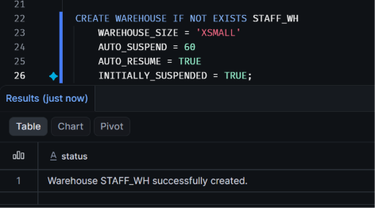

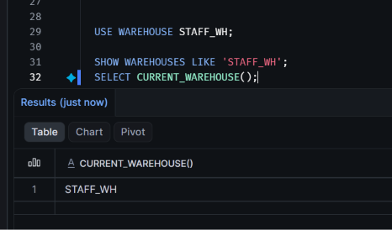

PART 3: TABLE CREATION
Step 5: Create an Employee Table
Objective: To create an employee details table inside the COMPANY_DATA database and HR_RECORDS schema.
SQL Command:
CREATE TABLE IF NOT EXISTS
COMPANY_DATA.HR_RECORDS.EMPLOYEE_DETAILS
(
EMPLOYEE_ID NUMBER(10,0),
EMPLOYEE_NAME VARCHAR(100),
DEPARTMENT VARCHAR(50),
SALARY NUMBER(12,2),
LOCATION VARCHAR(100)
);
Explanation:
- CREATE TABLE creates a new table.
- IF NOT EXISTS prevents an error if the table already exists.
- EMPLOYEE_ID stores the employee identification number.
- EMPLOYEE_NAME stores the employee name.
- DEPARTMENT stores the employee's department.
- SALARY stores the employee's salary.
- LOCATION stores the employee's location.
Table Structure:
Column | Data Type | Purpose
EMPLOYEE_ID | NUMBER(10,0) | Employee identifier
EMPLOYEE_NAME | VARCHAR(100) | Employee name
DEPARTMENT | VARCHAR(50) | Department
SALARY | NUMBER(12,2) | Employee salary
LOCATION | VARCHAR(100) | Employee location
Verification Command:
SHOW TABLES LIKE 'EMPLOYEE_DETAILS'
IN SCHEMA COMPANY_DATA.HR_RECORDS;
Check Table Structure:
DESCRIBE TABLE COMPANY_DATA.HR_RECORDS.EMPLOYEE_DETAILS;
Observation: The EMPLOYEE_DETAILS table was created successfully with five columns and their respective data types.

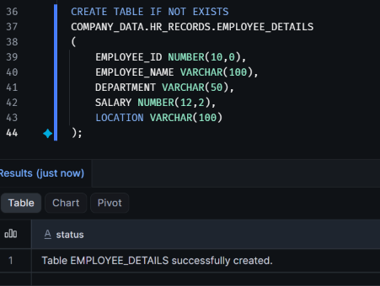
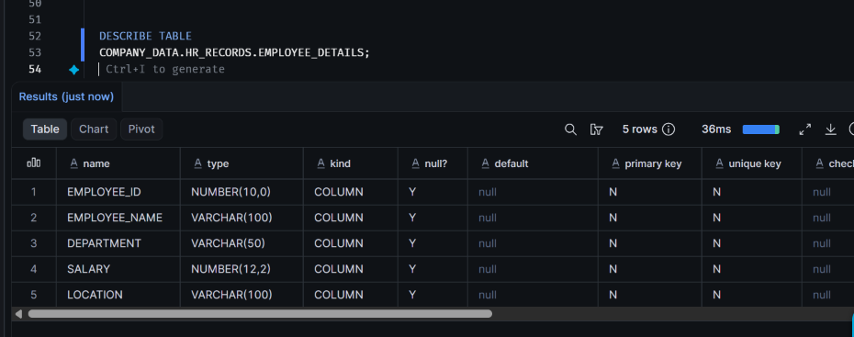

PART 4: FILE FORMAT CREATION
Step 6: Create a CSV File Format
Objective: To create a CSV file format that defines how Snowflake reads and interprets CSV files during data loading.
SQL Command:
CREATE FILE FORMAT IF NOT EXISTS
COMPANY_DATA.HR_RECORDS.STAFF_CSV_FORMAT
TYPE = CSV
SKIP_HEADER = 1
FIELD_OPTIONALLY_ENCLOSED_BY = '"'
EMPTY_FIELD_AS_NULL = TRUE;
Explanation:
- CREATE FILE FORMAT creates a named file format.
- STAFF_CSV_FORMAT is the file format name.
- TYPE = CSV specifies the CSV file type.
- SKIP_HEADER = 1 skips the first row containing column names.
- FIELD_OPTIONALLY_ENCLOSED_BY = '"' handles values enclosed in double quotes.
- EMPTY_FIELD_AS_NULL = TRUE converts empty fields into NULL values.
Verification Command:
SHOW FILE FORMATS
IN SCHEMA COMPANY_DATA.HR_RECORDS;
View File Format Properties:
DESCRIBE FILE FORMAT
COMPANY_DATA.HR_RECORDS.STAFF_CSV_FORMAT;
Observation: The STAFF_CSV_FORMAT file format was created successfully with CSV parsing settings. It is configured to skip the header row, handle double-quoted fields, and interpret empty fields as NULL values.
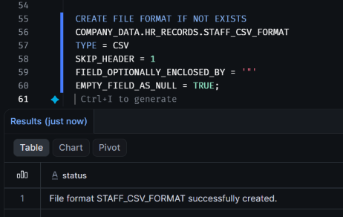
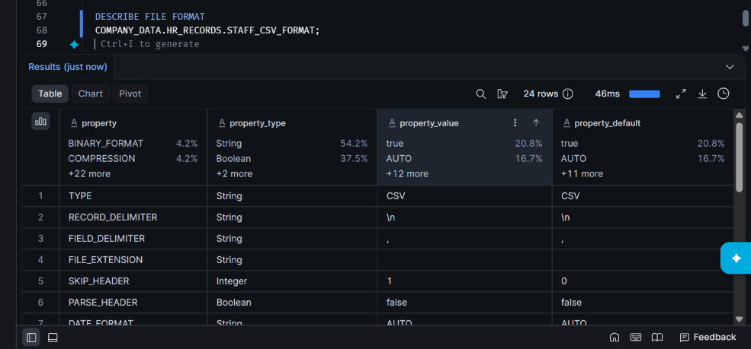

PART 5: INTERNAL STAGE MANAGEMENT
Step 7: Create an Internal Stage
Objective: To create an internal stage in Snowflake for storing CSV files before loading them into database tables.
SQL Command:
CREATE STAGE IF NOT EXISTS
COMPANY_DATA.HR_RECORDS.STAFF_STAGE
FILE_FORMAT = COMPANY_DATA.HR_RECORDS.STAFF_CSV_FORMAT;
Explanation:
- CREATE STAGE creates a named stage in Snowflake.
- IF NOT EXISTS prevents an error if the stage already exists.
- STAFF_STAGE is the name of the internal stage.
- FILE_FORMAT specifies the CSV file format associated with the stage.
- STAFF_CSV_FORMAT is the previously created file format.
Verification Command:
SHOW STAGES
IN SCHEMA COMPANY_DATA.HR_RECORDS;
List Files Inside the Stage:
LIST @COMPANY_DATA.HR_RECORDS.STAFF_STAGE;
Observation: The STAFF_STAGE internal stage was created successfully and associated with the STAFF_CSV_FORMAT file format. The stage is ready to receive employee CSV files.

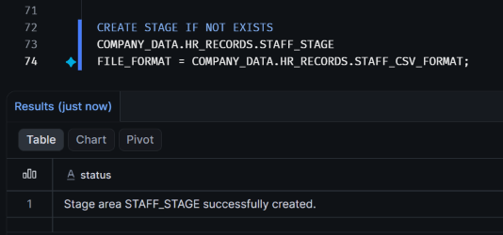
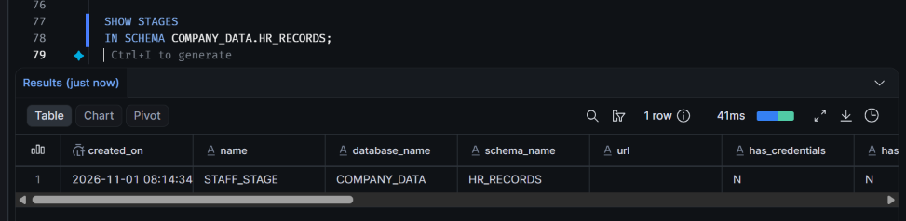
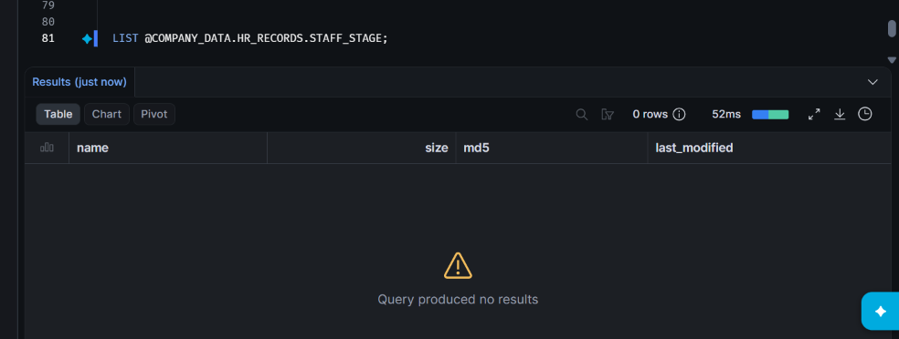

PART 6: FILE PREPARATION AND DATA UPLOAD
Step 8: Prepare and Upload the CSV File
Objective: To prepare an employee CSV file and upload it into the Snowflake internal stage.
File Name: staff_records.csv
Dataset Description: The CSV file contains eight employee records with the following columns:
- EMPLOYEE_ID
- EMPLOYEE_NAME
- DEPARTMENT
- SALARY
- LOCATION
Data Preparation: The employee records were prepared in CSV format using Notepad and saved as staff_records.csv.
Upload Procedure:
- Open the Snowflake Snowsight interface.
- Navigate to the COMPANY_DATA database.
- Open the HR_RECORDS schema.
- Select the STAFF_STAGE internal stage.
- Use the Upload Files option to select and upload staff_records.csv.
Verification Command:
LIST @COMPANY_DATA.HR_RECORDS.STAFF_STAGE;
Observation: The employee CSV file was uploaded to the STAFF_STAGE internal stage and verified using the LIST command.
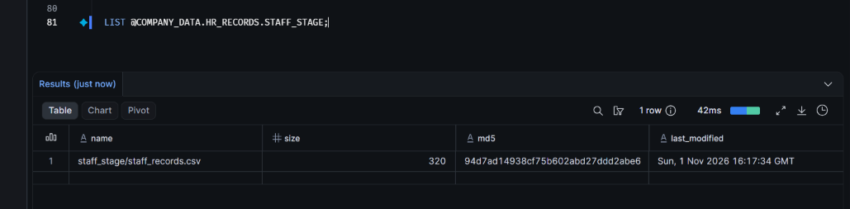

PART 7: LOADING DATA INTO SNOWFLAKE
Step 9: Load CSV Data Using COPY INTO
Objective:
To load employee records from the CSV file uploaded to the internal stage into the EMPLOYEE_DETAILS table using Snowflake's COPY INTO command.
SQL Command:
COPY INTO COMPANY_DATA.HR_RECORDS.EMPLOYEE_DETAILS
FROM @COMPANY_DATA.HR_RECORDS.STAFF_STAGE
FILE_FORMAT = (
FORMAT_NAME =
'COMPANY_DATA.HR_RECORDS.STAFF_CSV_FORMAT'
)
ON_ERROR = 'ABORT_STATEMENT';
Explanation:
- COPY INTO loads data from a staged CSV file into a Snowflake table.
- The destination table is COMPANY_DATA.HR_RECORDS.EMPLOYEE_DETAILS.
- The FROM clause specifies the internal stage containing the CSV file.
- FILE_FORMAT specifies the previously created CSV file format.
- ON_ERROR = 'ABORT_STATEMENT' stops the loading operation if an error occurs.
Execution Result:
Property | Result
File status | LOADED
Rows parsed | 8
Rows loaded | 8
Errors seen | 0
Observation:
The CSV file was successfully loaded into the EMPLOYEE_DETAILS table. Snowflake parsed all 8 employee records and loaded all 8 rows without encountering any errors.
Screenshot:
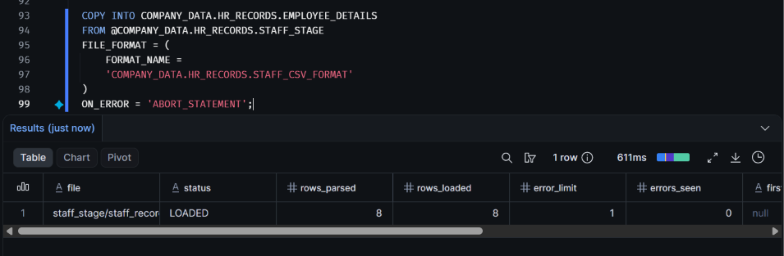

PART 8: DATA VERIFICATION
Step 10: Verify the Loaded Employee Records
Objective:
To verify the employee records loaded into the EMPLOYEE_DETAILS table and confirm the total number of records.
Query 1: Display All Records
SELECT *
FROM COMPANY_DATA.HR_RECORDS.EMPLOYEE_DETAILS;
Query 2: Count Total Employees
SELECT COUNT(*) AS TOTAL_EMPLOYEES
FROM COMPANY_DATA.HR_RECORDS.EMPLOYEE_DETAILS;
Query 3: Display the First Five Records
SELECT *
FROM COMPANY_DATA.HR_RECORDS.EMPLOYEE_DETAILS
LIMIT 5;
Explanation:
- SELECT * retrieves all columns and records from the employee table.
- COUNT(*) calculates the total number of records in the table.
- LIMIT 5 restricts the query output to the first five records.
Observation:
The employee records were successfully retrieved from the EMPLOYEE_DETAILS table. The COUNT(*) query confirms that 8 employee records are present in the table.
Result:
The CSV data was successfully loaded and verified in Snowflake.
Screenshots:


